Ex No: 09
Introduction To Honeypots
Aim:
To understand the concept of honeypots and their role in detecting and analyzing cyber attacks.
To learn how honeypots are deployed to monitor malicious activities and gather threat intelligence.

Procedure:
- Log in to the TryHackMe platform and open the Introduction to Honeypots room.
- Study the basic concept of honeypots and how they simulate vulnerable systems to attract attackers.
- Access the provided honeypot environment and interact with it using commands such as SSH and system queries.
- Analyze attacker activities, logs, and behaviours captured within the honeypot system.
- Answer the given tasks by identifying tools, commands, and malicious actions observed during the simulation.

Task 1: Introduction
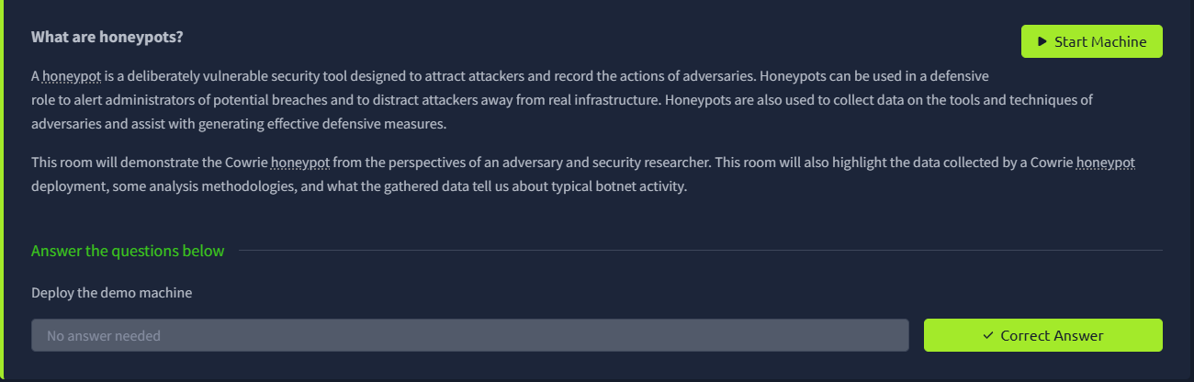

Task 2: Types of Honeypots
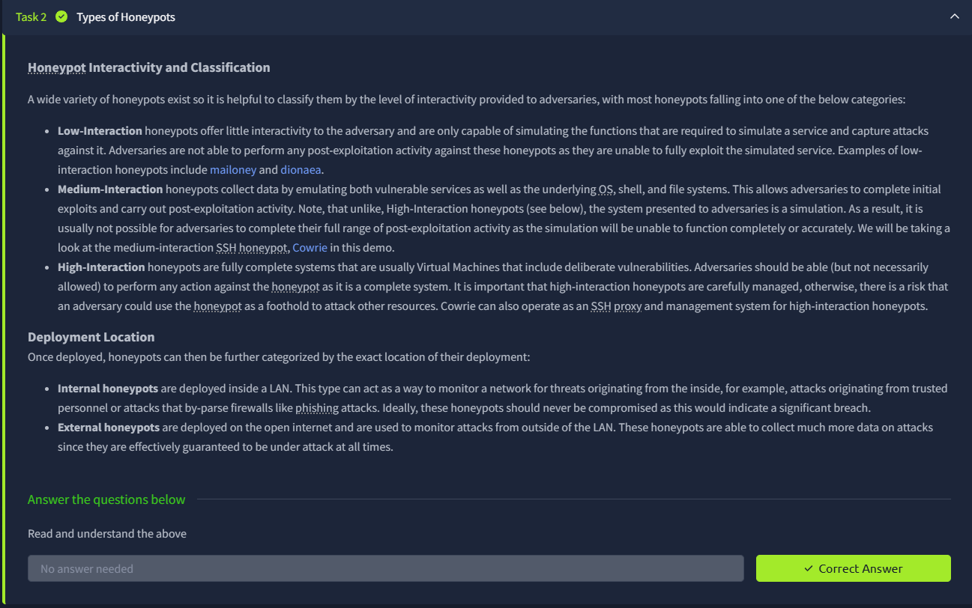

Task 3: Cowrie Demo
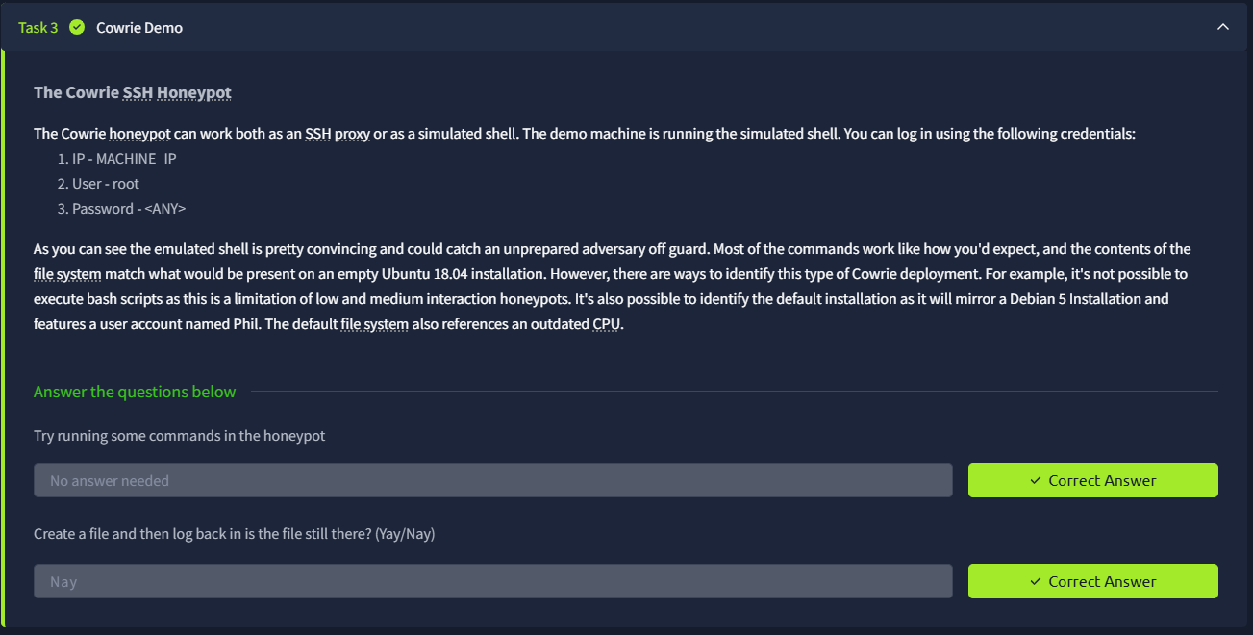

Task 4: Cowrie Logs
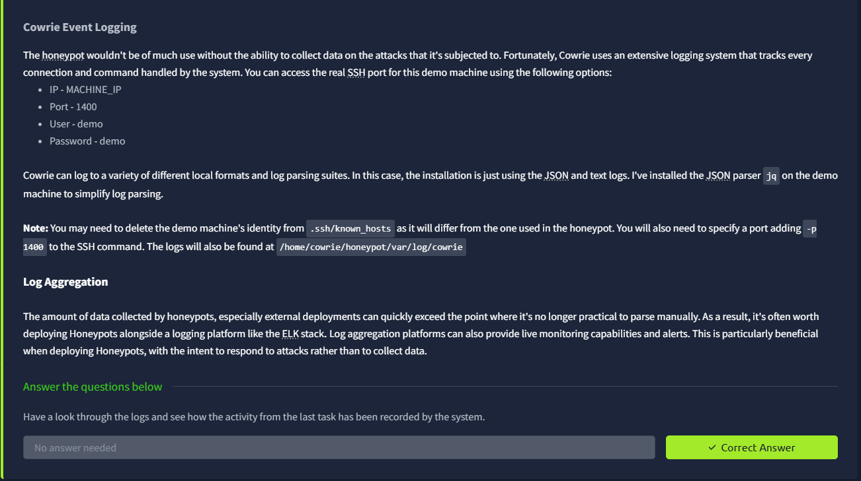

Task 5: Attacks Against SSH
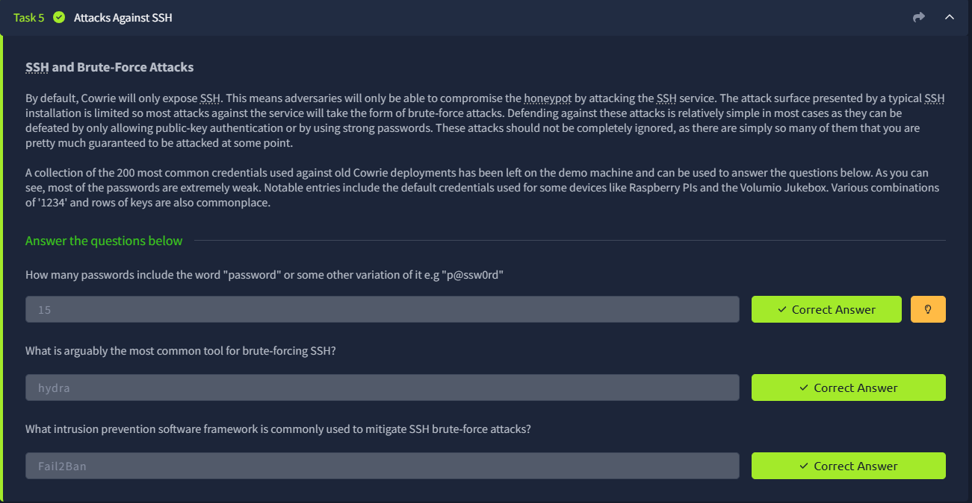

Task 6: Typical Bot Activity
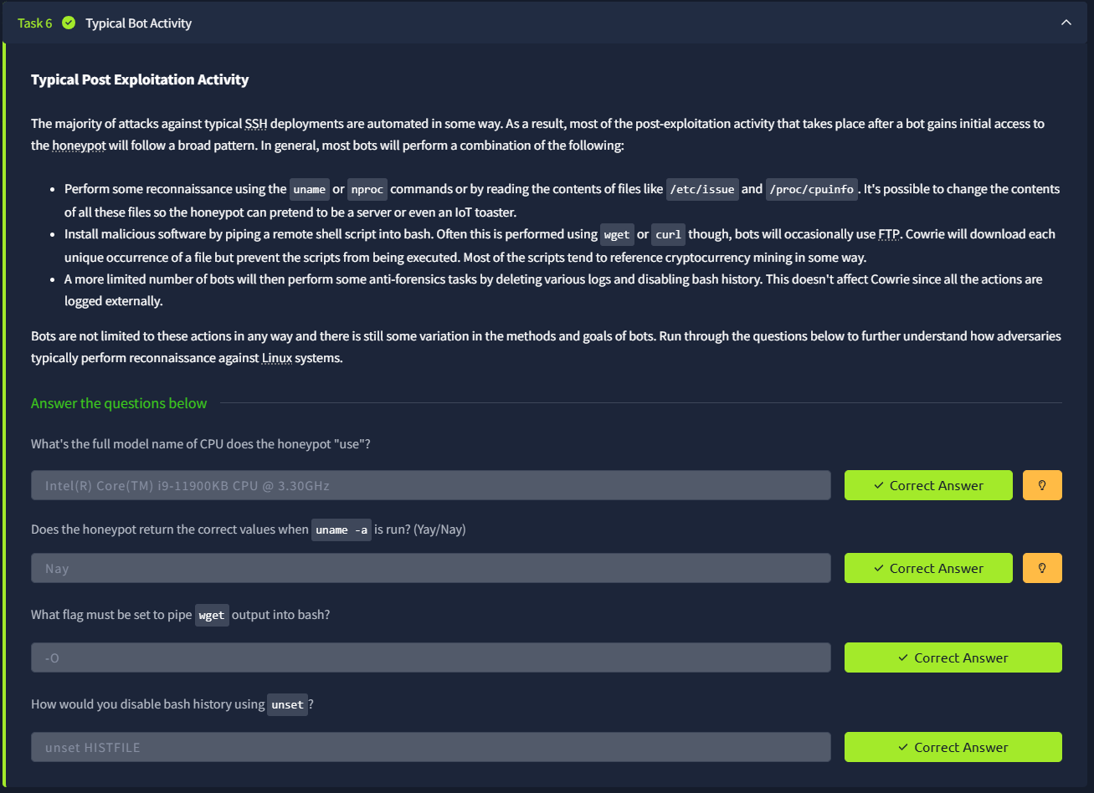

Task 7: Identification Techniques
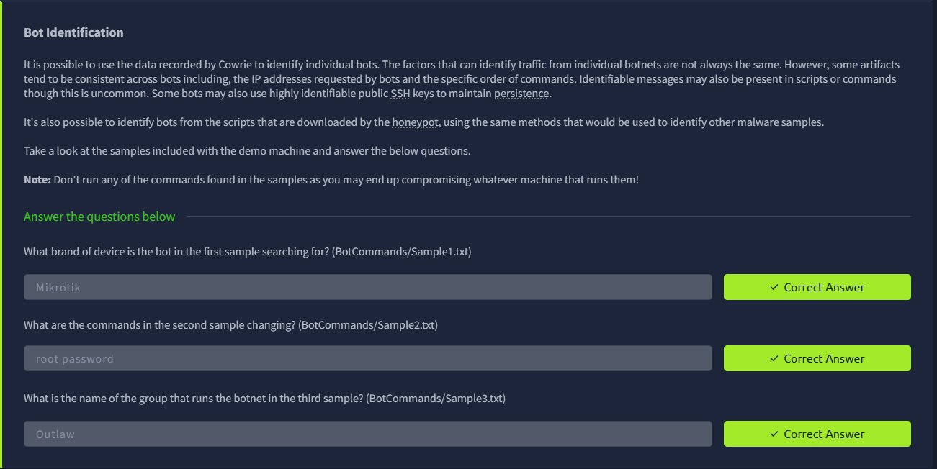

Task 8: SSH Tunnelling
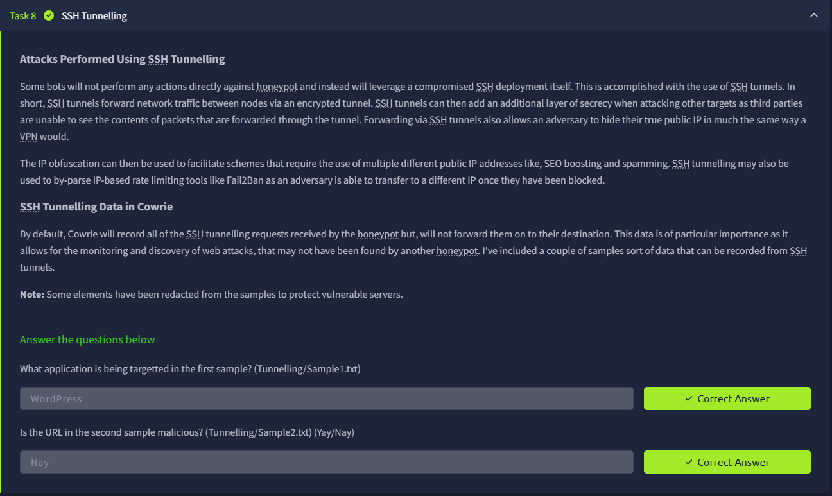

Task 9: Recap and Extra Resources
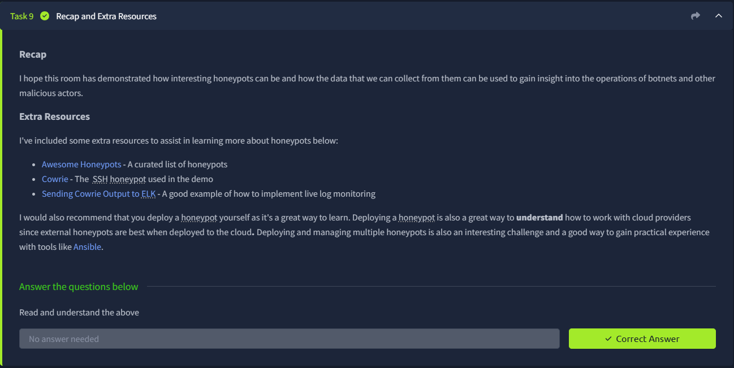

Result:
Successfully understood the working of honeypots and their importance in cybersecurity for detecting threats.
Gained practical knowledge in analyzing attacker behaviour and collecting useful security data using honeypot systems.

